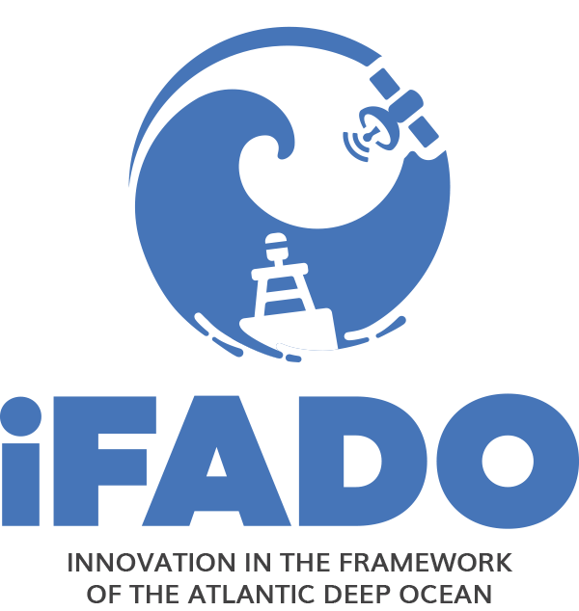

.

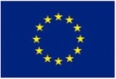 | This work was performed within the iFADO Project (Innovation in the Framework of the Atlantic Deep Ocean), with the support of the European Regional Development Fund trough the Interreg Atlantic Area Programme, under EAPA_165/2016

iFADO - Innovation in the Framework of the Atlantic Deep Ocean
funded by INTERREG Atlantic Area Programme under contract EAPA_165/2016

Memorandum of Understanding

Between

iFADO partner XXX, address, represented by…
hereinafter referred as XXX

and

Company YYY, address, represented by…
hereinafter referred as YYY

- Preamble
Whereas European countries have to implement the EU Marine Strategy Framework Directive (MSFD) by following an adaptive management approach in their Territorial Waters and Exclusive Economic Zones and achieve Good Environmental Status (GES) by 2020;

Whereas European countries and regions bordering the Atlantic Ocean - Ireland, United Kingdom, France, Spain and Portugal – are faced with the great challenge of characterising and monitoring an extensive area;

Whereas the iFADO project aims to assist national and regional competent authorities in the implementation of the EU Marine Strategy Framework Directive in the Atlantic, particularly in the open ocean, where it seeks to achieve regionally coherent, coordinated and consistent description and updates of Good Environmental Status;

Whereas the iFADO project aims to create marine services at regional and subregional scale, combining traditional monitoring with state-of-the-art and innovative technologies, towards the characterisation and the monitoring of the 11 GES descriptors: Enhanced in situ monitoring, new technologies for in situ monitoring, remote sensing and numerical modeling;

Whereas the iFADO project also wishes to achieve greater involvement of the Scientific Community, Industry and Citizens with MSFD competent authorities;

Whereas both parties recognise the mutual benefits that can arise from cooperation between the Scientific Community, Research and Industry, through innovation and technology transfer;

Whereas both parties seek to better integrate the innovation sector in the effective monitoring and support to the implementation of the Marine Strategy Framework Directive in the Atlantic Area;

Whereas both parties wish to explore the possibility and feasibility of cooperation within the iFADO project;

XXX and YYY agree as follows:

- Objective

The objective of this Memorandum of Understanding is to set a frame for cooperation between Industry and members of the iFADO consortium, in order to encourage and facilitate the involvement of Industry, and particularly Small and Medium-sized Enterprises (SMEs), in scientific missions whose purpose is to help implementing the EU Marine Strategy Framework Directive (MSFD) in the Atlantic Area.

- Role of the Parties

  - iFADO partner XXX

[Brief description of iFADO partner XXX]

XXX is committed to facilitate information of access and use of their stations, ships, facilities and equipment to YYY, under fair and reasonable conditions, wishing to test devices or deploy instrumentation related to the implementation of the MSFD, particularly the characterisation and the monitoring of the 11 GES descriptors.

  - Company YYY

[Brief description of company YYY]

YYY is committed to encourage testing or deploying of products whose purpose is to create or enhance services that will help to implement the MSFD, particularly the characterisation and the monitoring of the 11 GES descriptors.

- Management

Both parties will exchange details of respective points of contact in charge of managing the object of the MoU. Through that channel, they are willing to share the relevant information in order to facilitate the implementation of the MoU.

In particular:

  - iFADO partner XXX

XXX will notify YYY information of the availability of their facilities with the best reasonable notice and inform them of the most favorable periods for using these facilities.

XXX will notify the type of service, equipment or technology they use or seek in their own research or operational activity related to the implementation of the MSFD, in order to encourage cooperation on specific projects, should YYY wish to contribute with their relevant products or services.

  - Company YYY

YYY will favourably consider entering into cooperation with XXX on specific projects, should their product or service be relevant to XXX’s research or operational activity in relation with the implementation of the MSFD. YYY commits to act accordingly to the best international practices on Responsible Research and Innovation (RRI).

  - iFADO Network

Both parties are also encouraged to use the iFADO Network, an online meeting forum aiming to promote the exchange of information, knowledge and experience, facilitate the identification of scientific and technological offers and demands, and favour the development of innovative public-private initiatives.

Through the iFADO Network, XXX can advertise their needs and availability, and invite companies to dedicated workshops or test sessions. YYY can make themselves visible to the scientific community and announce their opportunities to test or deploy their equipment. YYY agrees that the provided personal data can be stored and used for distribution of the iFADO network email list (network@ifado.eu). YYY agrees that its organizational data can be displayed in the iFADO project webpage (www.ifado.eu). YYY agrees to receive information and newsletters from the iFADO project.

- Legal and Financial Conditions

  - Nothing in this MoU shall be construed as creating any legal relationship between the parties. This MoU is a statement of intent to foster genuine and mutually beneficial co-operation.

  - No financial or resource obligations are implied by this MoU.

  - The sole purpose of this document is to specify the framework for the discussion of future collaboration between the parties. Any further operations undertaken under this MoU, either simple use by YYY of XXX’s facilities or collaborative projects involving the 2 parties, will be subject to separate agreements or contracts containing specific terms and conditions, including appropriate financial considerations.

- Confidentiality

Neither of the parties is to disclose, directly or indirectly, any confidential information received from the other party to any third party without written consent, unless required by law.

- Intellectual property and data sharing

All intellectual property brought by each party to the relationship under this MoU remains in the ownership of that party. Ownership and management of any intellectual property developed in relation to an activity under this MoU, or any standards for data management and protocols for data sharing, are to be dealt with in the contractual agreement referred to in article 5.3.

- Health and Safety

Agreements entered into under article 5.3 include health and safety and, where appropriate, insurance provisions.

- Dispute Resolution
Any dispute concerning the subject matter of this MoU is to be settled by full and frank discussion and negotiation between the parties.

- Term
This MoU is effective from the date of signature, and expires on the 30th of November 2021 (duration of the iFADO project), unless both parties agree in writing to renew its term.
Either party may withdraw from the agreement by giving 3 month’s written notice to the other party.

All the clauses of this Agreement are intended to be legally binding, with the exceptions of clauses 1, 2, 3 and 4.

For the avoidance of doubt, the binding clauses of this MoU shall continue to apply to all Parties during the term established in this clause, notwithstanding any withdraw and termination.

- Signatures

For XXX  [representative name]  _____________________________________  Date:_________________________________ | For YYY  [representative name]  ____________________________________  Date:________________________________

Annex to the iFADO MoU
Good Environmental Status Descriptors
of the EU Marine Strategy Framework Directive

Descriptor 1 | Biodiversity is maintained. The quality and occurrence of habitats and the distribution and abundance of species are in line with prevailing physiographic, geographic and climatic conditions.
Descriptor 2 | Non-indigenous species introduced by human activities are at levels that do not adversely alter the ecosystems.
Descriptor 3 | Populations of all commercially exploited fish and shellfish are within safe biological limits, exhibiting a population age and size distribution that is indicative of a healthy stock.
Descriptor 4 | All elements of the marine food webs, to the extent that they are known, occur at normal abundance and diversity and levels capable of ensuring the long-term abundance of the species and the retention of their full reproductive capacity.
Descriptor 5 | Human-induced eutrophication is minimised, especially adverse effects thereof, such as losses in biodiversity, ecosystem degradation, harmful algae blooms and oxygen deficiency in bottom waters.
Descriptor 6 | Sea-floor integrity is at a level that ensures that the structure and functions of the ecosystems are safeguarded and benthic ecosystems, in particular, are not adversely affected.
Descriptor 7 | Permanent alteration of hydrographical conditions does not adversely affect marine ecosystems.
Descriptor 8 | Concentrations of contaminants are at levels not giving rise to pollution effects.
Descriptor 9 | Contaminants in fish and other seafood for human consumption do not exceed levels established by Community  legislation or other relevant standards.
Descriptor 10 | Properties and quantities of marine litter do not cause harm to the coastal and marine environment.
Descriptor 11 | Introduction of energy, including underwater noise, is at levels that do not adversely affect the marine environment.

The 11 Good Environmental Status descriptors are detailed in annex.
https://www.rri-tools.eu/about-rri

